Chapter 7
RESULT AND ANALYSIS

7. RESULT AND ANALYSIS

7.1 Index Page
The Admin and Employee can login with their respective credentials and access their home pages. The new Employee can register by entering unique user id and email id and clicking on Register button.

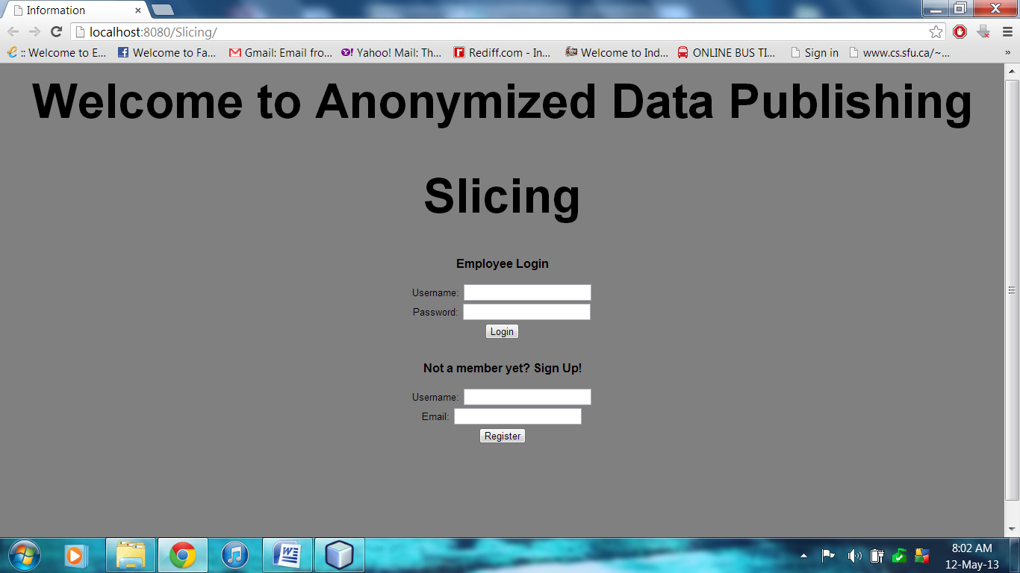
Figure 7.1 Index Page

7.2 Employee Registration
The new employee registers with the organization by entering his details like Name, User Id, Address, Designation, Email Id etc. An alert will be displayed when incorrect input is given. When user clicks on Register, we check in database whether the user Id is unique or already exists. If already exists, we display an error message.

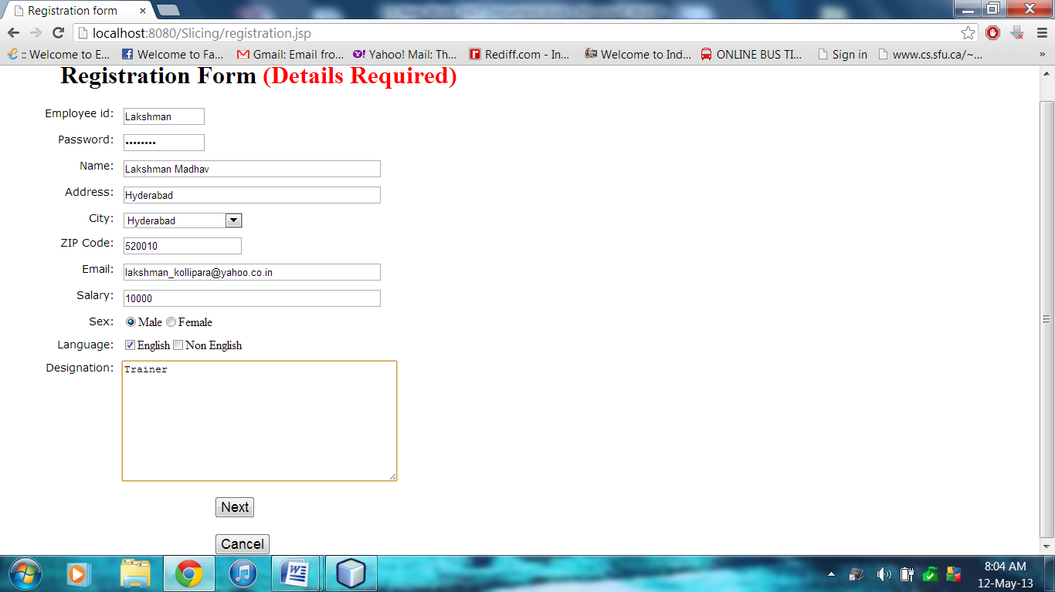
Figure 7.2 Employee Registration Form

7.3 Admin Menu
When admin logs into his account, admin menu is provided. Admin can view all users and manage users like updating the user details and deleting a user. Admin can also apply the anonymization techniques such as generalization, bucketization, slicing on the dataset.

Figure 7.3.1 shows the operations of Admin, Figure 7.3.2 shows the all users present in the organization, Figure 7.3.3 shows the update of user details and Figure 7.3.4 shows the deletion of users by Admin.

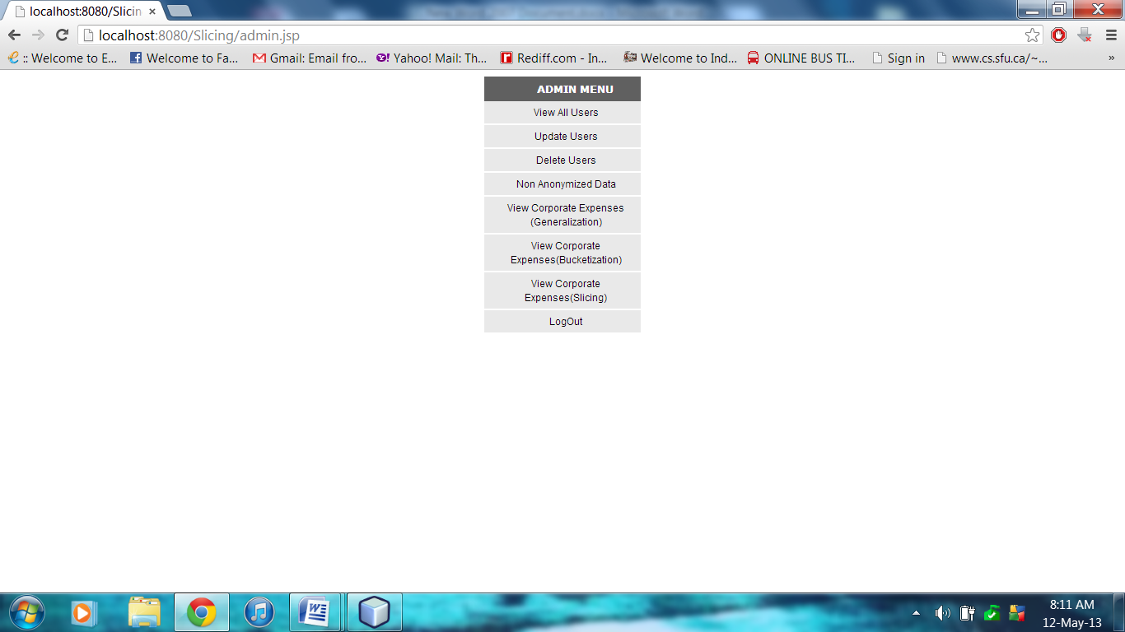
Figure 7.3.1 Admin Menu

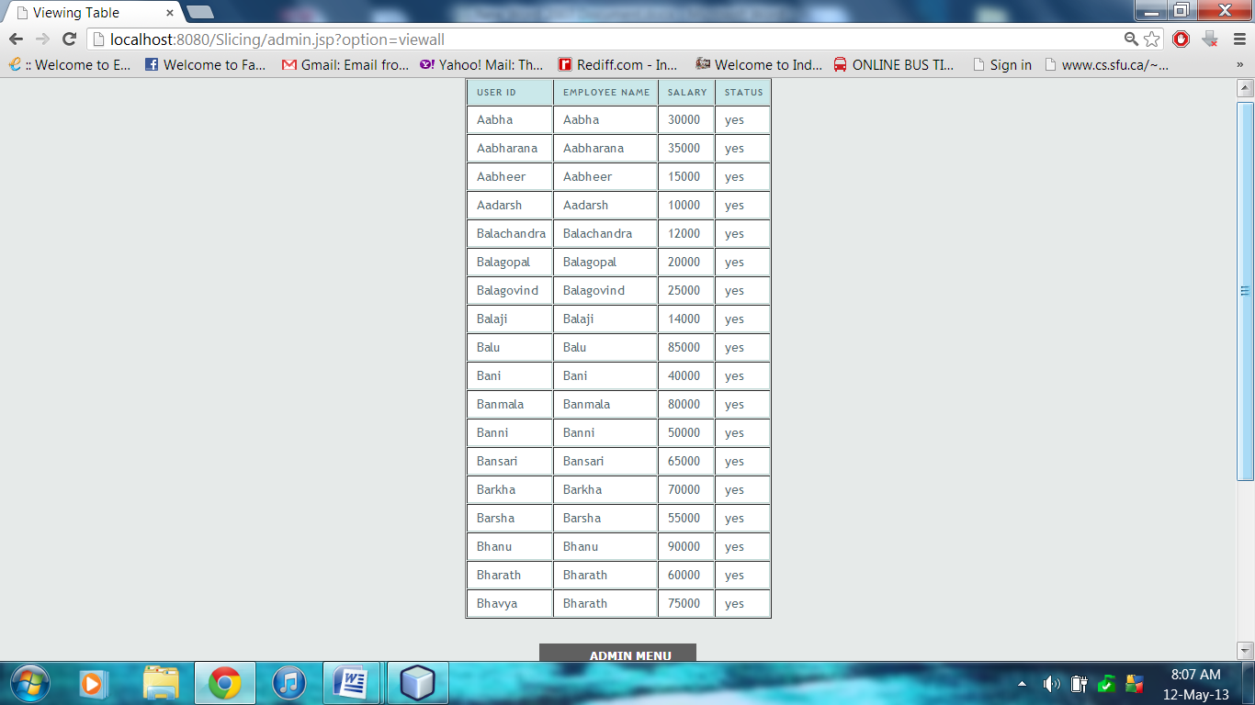
Figure 7.3.2 View All Users

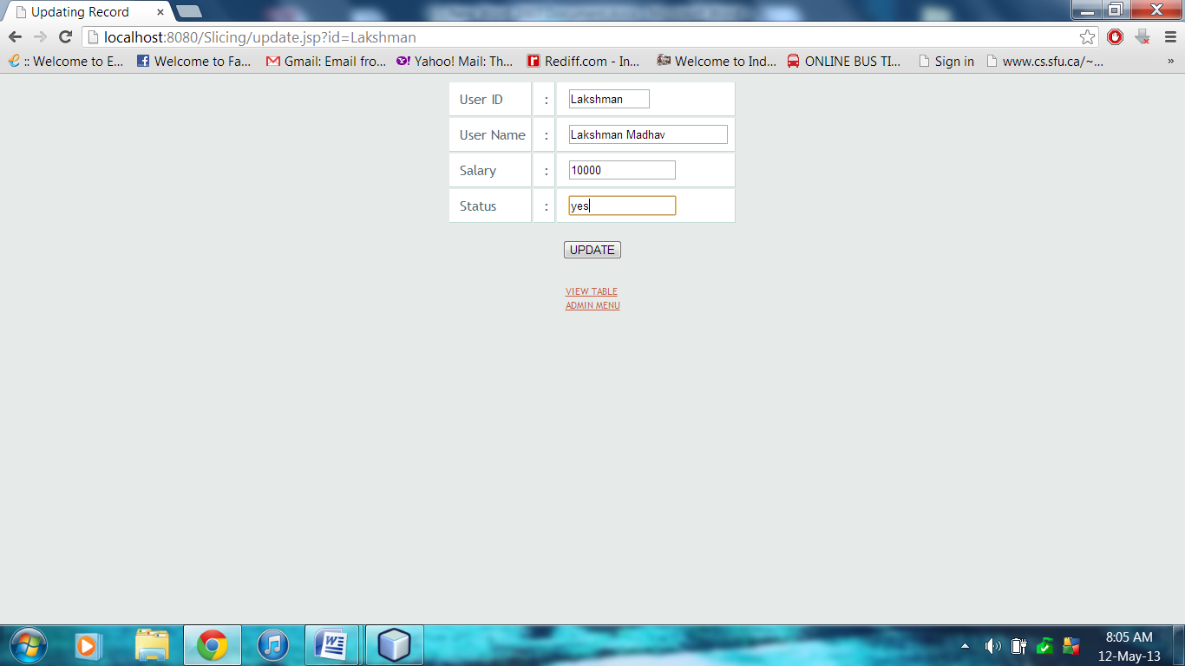
Figure 7.3.3 Update Users
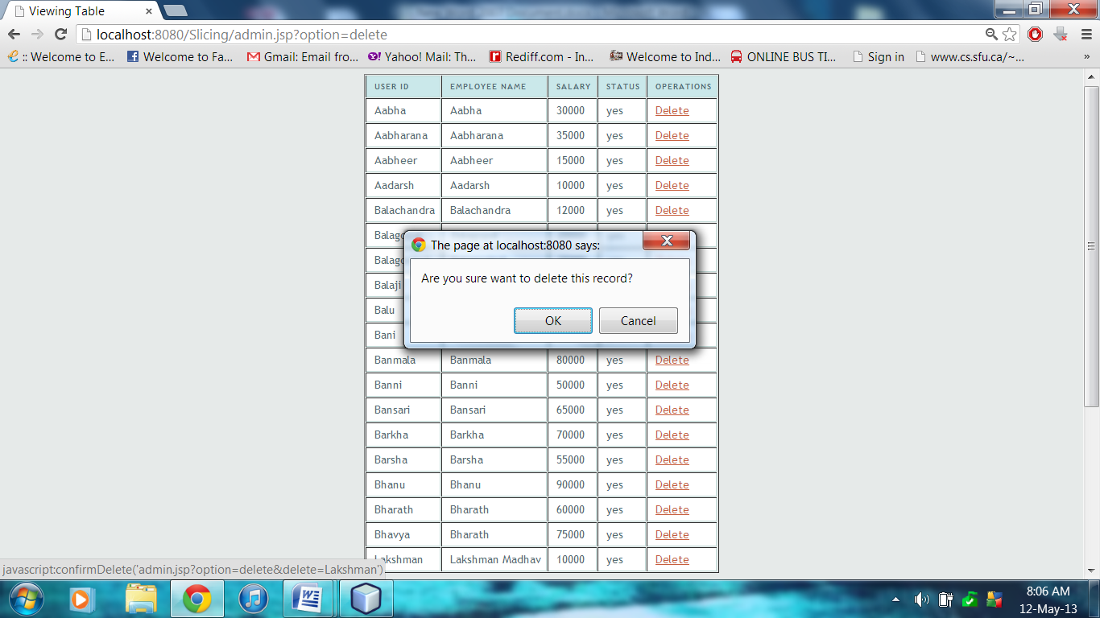
Figure 7.3.4 Delete Users

7.3.1 Non Anonymized Data
Figure 7.3.1 gives the data to be published before applying any anonymization techniques. If we publish this data in original form, Individual privacy is lost. So we apply the anonymization techniques on data to be published.

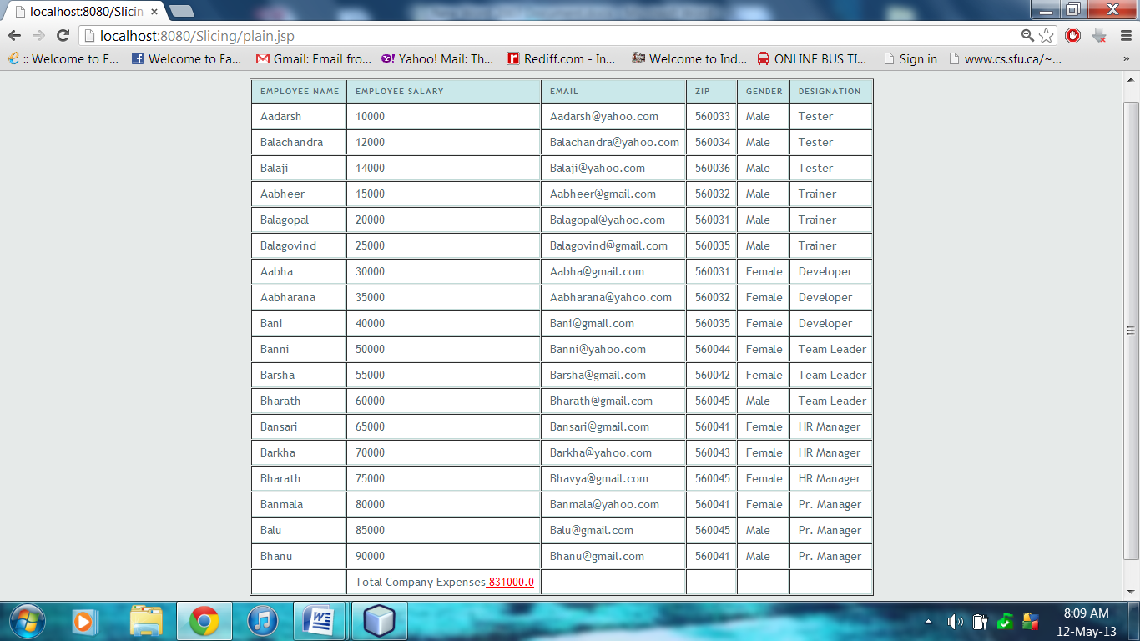
Figure 7.3.1.1 Non Anonymized Data

7.3.2 Generalization
In generalization, we remove the identifiers and we generalize the values i.e. less specific but consistent values. In our Scenario, we applied generalization on employee salary, email id, zip code and gender .We generalized the salary of employees into two ranges such that all employees will fall under those two ranges. We generalized the last digit of zip code such that few people have same generalized zip code. We generalized the gender by keeping ‘*’ such a way that no individual is linked to his record. Figure 7.3.2 shows the Generalized Table

Now the table satisfies the k-anonymity and attribute linkage and record linkage is protected and the probability of linking a person to his sensitive attribute is never more than 1/3.
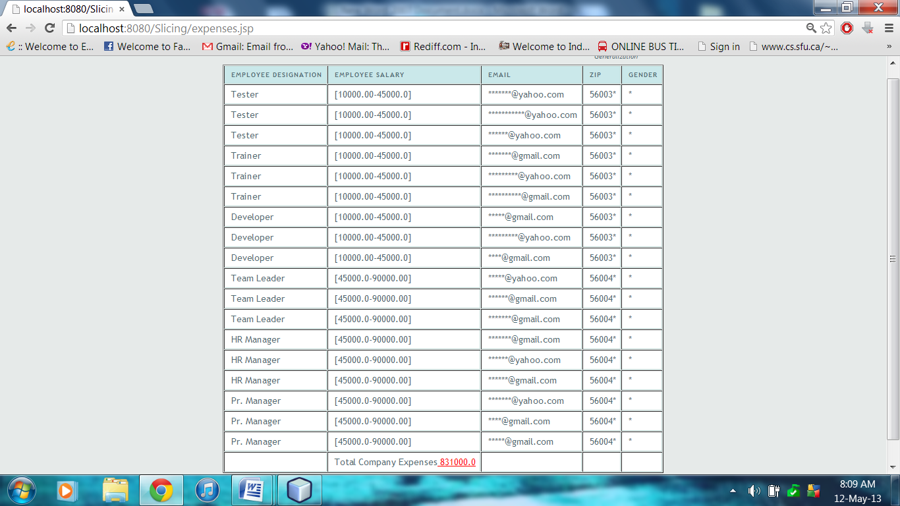
Figure 7.3.2.1 Generalized Data

7.3.3 Bucketization
In Bucketization, we remove the identifiers and the Sensitive Attributes are clearly separated from Quasi Identifiers and are randomly permutated breaking the correlations.In our scenario, the sensitive Attribute i.e. designation is separated from other quasi identifiers and the designations of employees are randomly shuffled. It prevents attribute linkage and record linkage but doesn’t prevent Membership Disclosure because the Quasi Identifiers are present in their original form. Figure 7.3.3 shows the Bucketized Table.

Bucketization offers better data utility than Generalization because all the values are in their original forms. The probability of linking a person to his sensitive attribute is never more than 1/6.

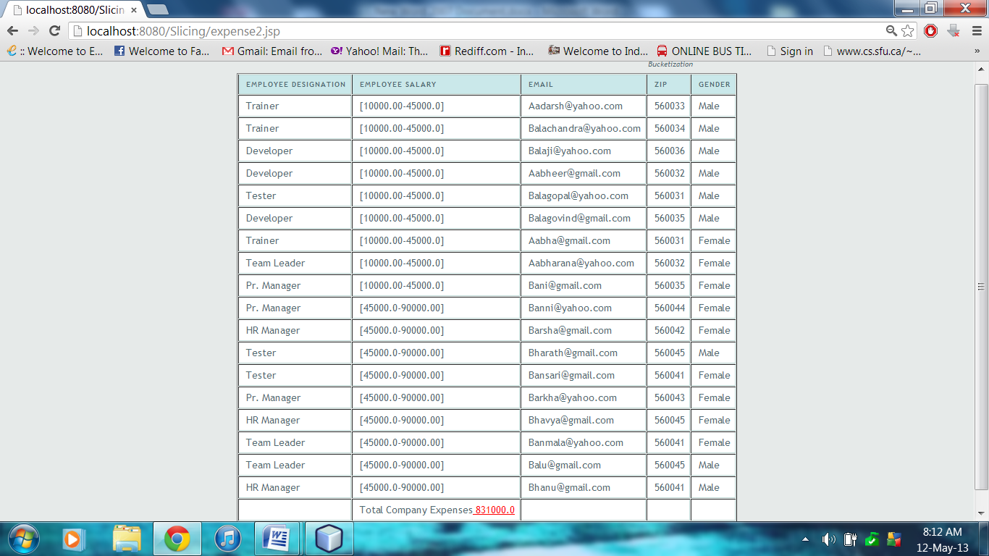
Figure 7.3.3.1 Bucketized Data

7.3.4 Slicing
Slicing partitions the data set both vertically and horizontally. Vertical partitioning is done by grouping attributes into columns based on the correlations among the attributes. Each column contains a subset of attributes that are highly correlated. Horizontal partitioning is done by grouping tuples into buckets. Finally, within each bucket, values in each column are randomly permutated (or sorted) to break the linking between different columns. The basic idea of slicing is to break the association cross columns, but to preserve the association within each column.In our scenario, Designation and Salary are correlated attributes which we group together for better data utility and we randomly permute both salary and designation together for better data privacy.

Slicing offers better data utility than Generalization and Bucketization because the highly correlated attributes are grouped together. Slicing offers better data privacy than above techniques by randomly permutating the grouped attributes, which results in less probability of 1/108 for linking a person to his sensitive attribute.

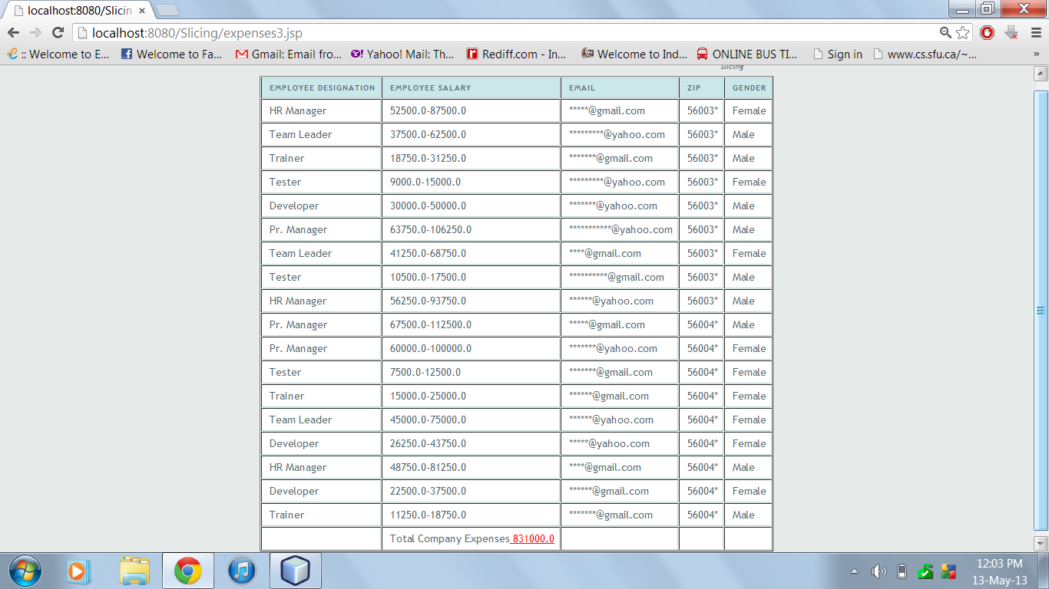
Figure 7.3.4.1 Sliced Data

7.4 Employee Menu
When employee logs into his account, an employee menu is provided where employee can view his self details and logout.

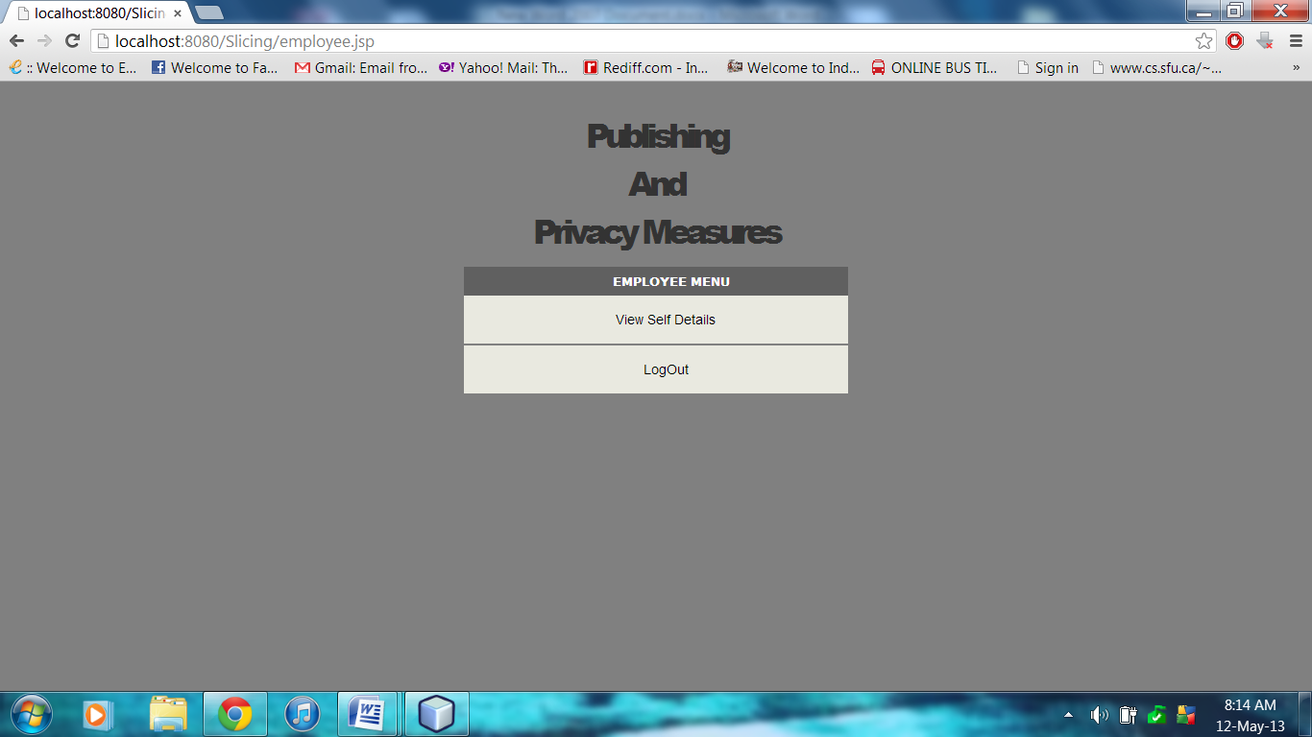
Figure 7.4.1 Employee Menu

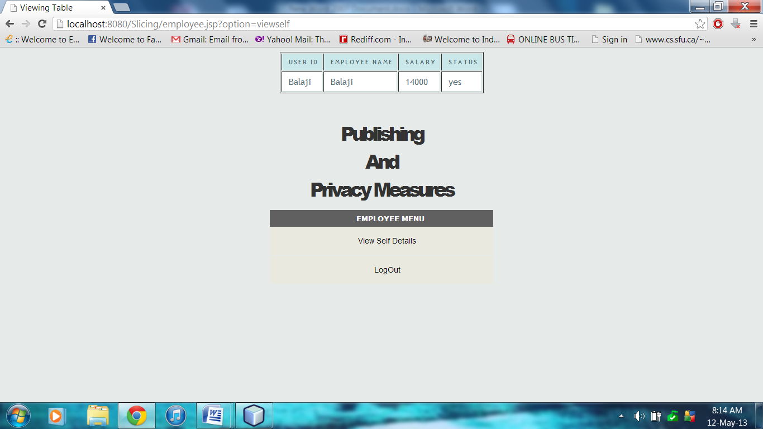
Figure 7.4.2 Employee Self Details

